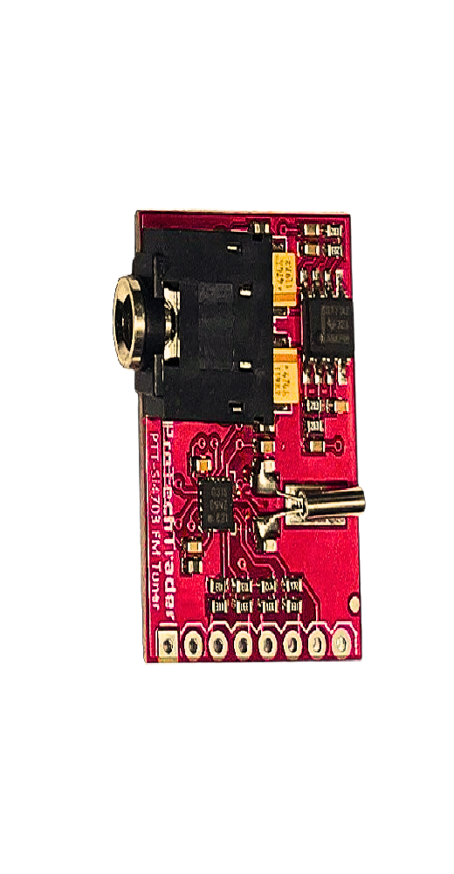

* ProTechTrader's Si4703 is Designed to be compatible replacement of the SparkFun FM Tuner Evaluation Board WRL-12938 V13 with matching pinout of GND 3.3V SDIO SCLK SENRST GP101 GP102

**Note**: This matches the latest style (v13) with the 3.3v and GND pins switched compared to the older V11 SparkFun WRL-10663 breakout board

* Enables you to tune and receive FM radio stations & the Si4703 is also capable of detecting and processing both Radio Data Service (RDS) and Radio Broadcast Data Service (RBDS) information
* Communication interface: 3-wire system (maximum 2.5MHz)

Module default comm: 2-wire system IIC (maximum 400KHz)

**Note:** Soldered Header not Included

* Brand / Model – ProTechTrader PTT-Si4703

(Replaces - **SparkFun WRL-12938 V13)**

* Breakout Board using Silicon Labs Si4703 RF Chip
* Product Type – Prototyping Circuit Evaluation Board
* Radio Frequency (RF) FM Tuner Range - 76 MHz to 108 MHz
* Module operating voltage: 3.3V
* Programmable de-emphasis (50us/70us)

**Product Overview**

This is an evaluation board for the Silicon Laboratories Si4703 FM tuner chip. Beyond enabling you to tune in to FM radio stations, the Si4703 is also capable of detecting and processing both Radio Data Service (RDS) and Radio Broadcast Data Service (RBDS) information. The Si4703 even does a very good job of filtering and carrier detection. It also enables data such as the station ID and song name to be displayed to the user.

Using this board, you will be able to pick up multiple stations just as well as with a standard FM radio. The board breaks out all major pins and makes it easy to incorporate this great chip into your next radio project. The power bus, the 3.3V and GND pins are broken out For communication. The breakout provides access to SDIO and SCLK for I2C communication while RST can be used for easy resetting. The SEN pin enables the user to change the mode of functionality of the IC. The last two pins broken out are GPIO1 and GPIO2 which can be used as general input/output pins, but also can be used for things like the RDS ready, seeking or tuning functions.

Keep in mind, by plugging headphones into the 3.5mm audio jack, you effectively use the cable in your headphones as an antenna! Therefore, this board does not require an external antenna if using headphones or a 3.5mm audio cable longer than 3 feet.

Introduction

**Note:** This guide was written for the **ProTechTrader's PTT-SI4703 FM Radio Receiver Development Board** with is a direct replacement for the SparkFun Si4703 FM Tuner Evaluation Board V13 **(**[**WRL-12938**](https://www.sparkfun.com/products/12938)**)**. The 3.3V and GND pins are switched in the SparkFun v13 Revision of the board which is identical to the ProTechTrader PTT-SI4703. Make sure you connect to the correct power and ground pins if you are using an older board like the Sparkfun V11 ([WRL-10663](https://www.sparkfun.com/products/retired/10663)) or any of the generic clone boards from aliexpress or ebay as they will not match the proper pinout in this guide.

The [Si4703 FM tuner evaluation breakout board](https://www.protechtrader.com/si4703-fm-tuner-radio-breakout-evaluation-board-Sparkfun-WRL-12938-v13) enables you to tune in to FM radio stations, using the Si4703 FM tuner chip from Silicon Laboratories. This IC also works well for filter and carrier detection, and enables data such as the station ID and song name to be displayed to the user.

**Keep in mind you will also need standard soldering materials to complete this tutorial, as well as either a set of speakers or headphones with a 3.5mm jack to plug into the Si4703 board.

The Si4703 Breakout Board breaks out multiple pins from the IC. For the power bus, the 3.3V and GND pins are broken out. Keep in mind that while the IC is tolerant up to 5V, the communication pins are only 3.3V tolerant, and therefore should only be used in 3.3V systems. If you need to use this in a 5V system please consider using a logic level converter.

For communication, the breakout board provides access to SDIO and SCLK for I2C communication. The RST pin is also broken out for ease of resetting the module.

SEN is also broken out, and enables the user to change the mode of functionality of the IC. SEN is pulled high on the breakout board to enable I2C communication as mentioned previously. However, by changing the state of SEN along with SDIO, you can change the mode of functionality between a 3-wire interface and 2-wire interface.

Finally, the last two pins broken out are the GPIO1 and GPIO2 pins. These can be used as general input/output pins, but also can be used for things like the RDS ready, seeking or tuning functions.

The board does not have a built-in antenna on it. However, by using headphones or a 3 foot-long 3.5mm audio cable, the wires will function as an antenna and will therefore negate the need for an external antenna on the board. If you are not planning on using either of these, you will need to modify the board to add in an antenna.

**Hardware Overview**

* **Note!** This tutorial was written for[**ProTechTrader PTT-Si4703 Si4703 FM Tuner Evaluation Board**](https://www.protechtrader.com/si4703-fm-tuner-radio-breakout-evaluation-board-Sparkfun-WRL-12938-v13) which is fully pin compatiblereplacement for the **SparkFun** [WRL-12938](https://www.sparkfun.com/products/12938) v13
* The **ProTechTrader Si4703 Radio Frequency (RF) Breakout Board with RDS & the new SparkFun WRL-12938 V13 Development Board both have the GND Pin 1st followed by the 3.3v pin 2nd (GND → 3.3V → SDIO → SCLK → SEN → RST → GPIO1 → GPIO2)**
* **This is opposite on the older retired V11 (**WRL-10663) **boards and all of the Chinese clone boards you see on Aliexpress & eBay which have the obsolete pin order (3.3V GND SDIO SCLK SEN RST GPIO1 GPIO2)** and are not supported by this guide (note the GND & 3.3V pins are switched)

| Back of Si4703 Breakout Board |  |
| --- | --- |
| **SparkFun WRL-12938 V13 Development Board** *V13*  *Underside of breakout board showing pin labels* | **ProTechTrader PTT-Si4703** **FM Tuner Evaluation** Board  *Underside of breakout board showing pin labels* |

**Resources and Going Further**

Now that you have your FM Tuner up and tuned to your favorite stations, you can start tweaking your circuit. You could add volume controls, and RF frequency tuning buttons along with receiving RDS broadcast data and displaying it on a LCD screen such as done in the

If you come up with a really cool project or mod, let us know! We'd love to hear about it.

For more information about the Si4703 FM tuner evaluation board, check out the resources below:

* [ProTechTrader PTT-Si4703 FM Radio Tuner Development Evaluation Board Schematic](https://cdn.sparkfun.com/datasheets/Wireless/General/Si4703_Eval_v13.pdf)
* [ProTechTrader GitHub - Code Repository (Library, Example Code, & Design Files)](https://github.com/ProTechTrader)

[Silicon Labs Si4703 Datasheet (PDF)](https://cdn.sparkfun.com/assets/learn_tutorials/2/7/4/Si4703_datasheet.pdf)

* [Texas Instruments TPA6111A2 150-mW Stereo Audio Amplifier Datasheet (PDF)](https://cdn.sparkfun.com/assets/learn_tutorials/2/7/4/tpa6111a2_datasheet.pdf)
* [Silicon Labs AN230 Si4703 Programming Guide (PDF)](https://cdn.sparkfun.com/assets/learn_tutorials/2/7/4/AN230.pdf)
* [Silicon Labs AN243 Programming Guide Using RDS/RBDS with the Si4703 (PDF)](https://cdn.sparkfun.com/assets/learn_tutorials/2/7/4/AN243.pdf)